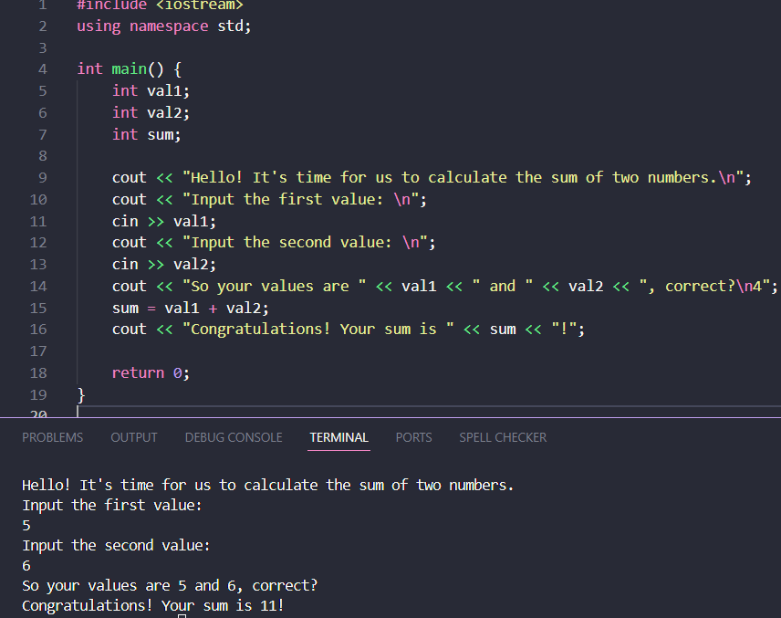#include <iostream>
using namespace std;

int main() {
int val1;
int val2;
int sum;

cout << "Hello! It's time for us to calculate the sum of two numbers.\n";
cout << "Input the first value: \n";
cin >> val1;
cout << "Input the second value: \n";
cin >> val2;
cout << "So your values are " << val1 << " and " << val2 << ", correct?\n4";
sum = val1 + val2;
cout << "Congratulations! Your sum is " << sum << "!";

return 0;
}

